

8

Eco District Newsletter
No 18 Autumn 2025

Welcome to the 18th edition of the newsletter produced by the Bristol District Environment Group. The focus of many people’s hearts and minds will be on the meeting of COP30 on Climate Change taking place in Brazil.

The COP meetings can seem to be an exercise in national self-interest with the rich and powerful maintaining their self-interest. But there uis a vital need for us not to give up. The recent destruction in Jamaica caused by Hurricane Melissa has emphasised the potential destructive power of climate change. The seas in the Caribbean have reached 30º C – wonderful for a holiday swim but also a source of generative power for tropical storms. The impact has been both human and economic. The argument that we cannot afford to take climate action needs to be countered by the clear statement that we cannot afford NOT to take action.
The next United Nations Climate Conference takes place on the Amazon from 10-21 November. Please commit this matter to prayer asking that the leaders of nations may be more deeply committed to caring for God’s creation and willing to lay aside their narrow self-interest. Please challenge those who dismiss climate action as ‘woke’ by setting out the facts of what is happening. Please contact your MP and ask them to press the British government to take bold steps.
But also please remember that alongside the climate emergency there is a growing destruction of wildlife and a loss of biodiversity. In this edition of the newsletter there is an example of what one church is doing to encourage wildlife. We have something over 150 churches in the District – how about 150 mini nature reserves. Then add on all those Methodist ‘home’ gardens and our impact could be massive.
HORFIELD METHODIST CHURH
EXCITING ECO NEWS
It’s been a busy year for the Eco Group at Horfield – with 4 eco projects starting.
Courtyard Development – an outside space we desperately need, and a real Eco Haven
We wanted to create an area with a strong eco focus, which would be supported by information outlining the work we are doing, for use by various church community groups – with features including seating, LED lighting, water feature, water butt, eco information boards and relevant spiritual/reflective texts, planters with local plants to encourage pollinators. The project started with some major work being carried out to the paths – the surface was not safe or fit for purpose.
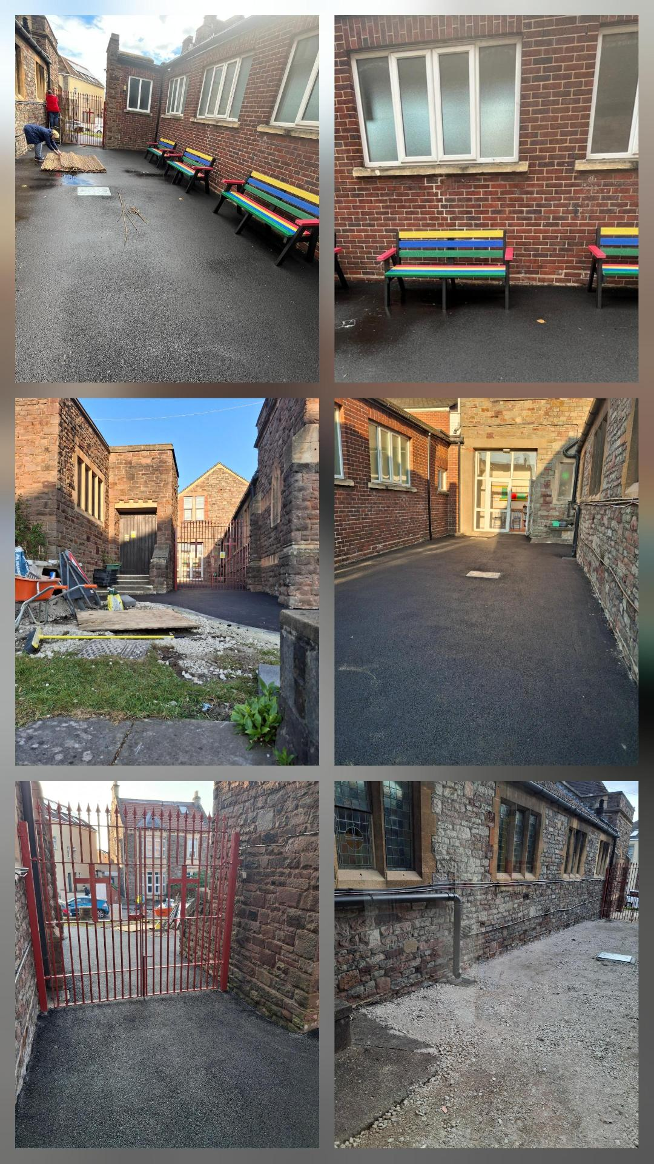
The development gives us the outside space we desperately need. The aim is to make this a real Eco haven – accessed and used by all ages. It will be a chance for all to learn about, and get hands on with, issues, including those, that local pollinators face. This will give us an opportunity to show, through the inclusion of relevant bible texts and messages (on the information boards), that to love God, is to love and care for his creation.

The project continues to progress well. All path work, drains and guttering work has been completed. We have now started on filling the area with planters and furniture etc. The aim is the have everything ready for Spring 2026. You can see from the attached photos the new shed. benches and planters are in. Each bench has been made with over a 1000 recycled plastic bottles and the shed was purchased from a company with great Eco credentials - they are heavily involved in tree planting schemes and use sustainable timber.
There are things still to do, but thanks to grants from the District and Circuit, a lot has already been accomplished.
Remote Access Controllers (Hive) system
Horfield has 5 boilers, heating various zones of our large premises - each had to be set individually and adjusted manually, depending on the user bookings/events taking place. This involved travelling to and from the premises any time a booking was changed or a last-minute room booking received.
We applied for a grant from District to help with the cost of installing remote access controllers. These would make the system much more efficient, and easy to control. Our Hive system has been installed and is now up and running. Being able to sort the heating without visiting the premises is already making a difference.
Bike Racks
We used the £500 Circuit Eco grant to help fund the installation of 5 bike racks. They have only been in use a few weeks and they are already being used.
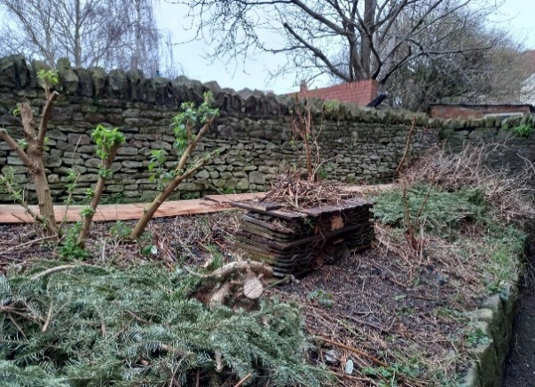
Bug Village
Members of our Junior Church added to the work already done by our gardening group, and we now have a thriving bug village! There are lots of buildings, leaf and stick piles, logs etc for all of our bugs and insects and little visitors to make their homes in and find shelter. We also have a hoverfly lagoon!
The first bug hotel

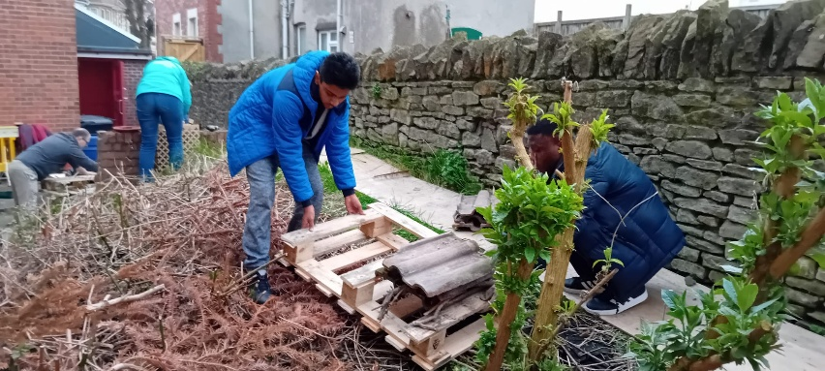

Hard at work on the next hotel Water for any visitors
A Hoverfly lagoon – the grass will rot down and hoverflies lay their eggs. The larvae crawl out using twigs and pupate in the ground. Then the hoverflies emerge

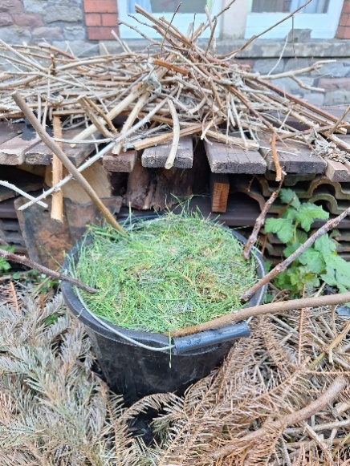

Picking up the threads of creation care
Creation needs nothing to make it more beautiful but Jacqui Parkinson’s amazing embroideries help you to see it in a new way. Jacqui’s amazing vibrant works of art, “Threads Through Creation” bring new ways of seeing the story of creation.
Over a period of six weeks in the autumn Victoria Methodist Church in Bristol hosted this exhibition and welcomed more than 2000 people who came to see these wonderful works of art and to be helped to appreciate the glory of God’s work and to gain new insights.
The Church says “It has been wonderful to see how much joy and pleasure it has given people. We are very grateful to those who planned, installed, stewarded, provided refreshments and much more to ensure the success of it all.”.
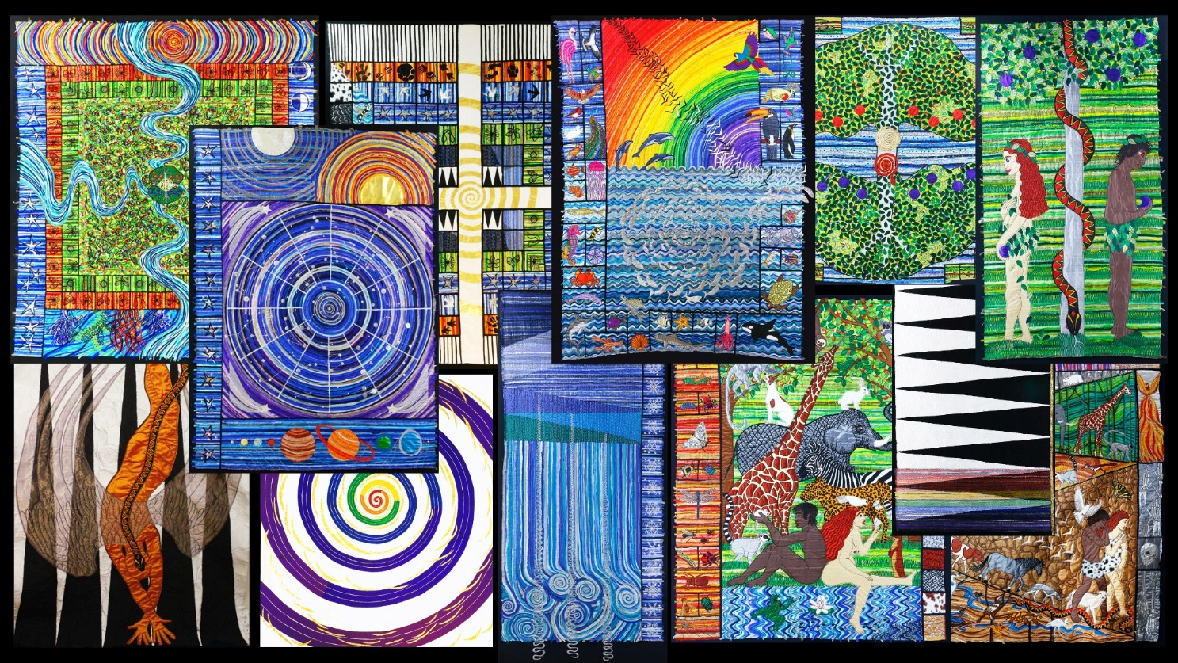

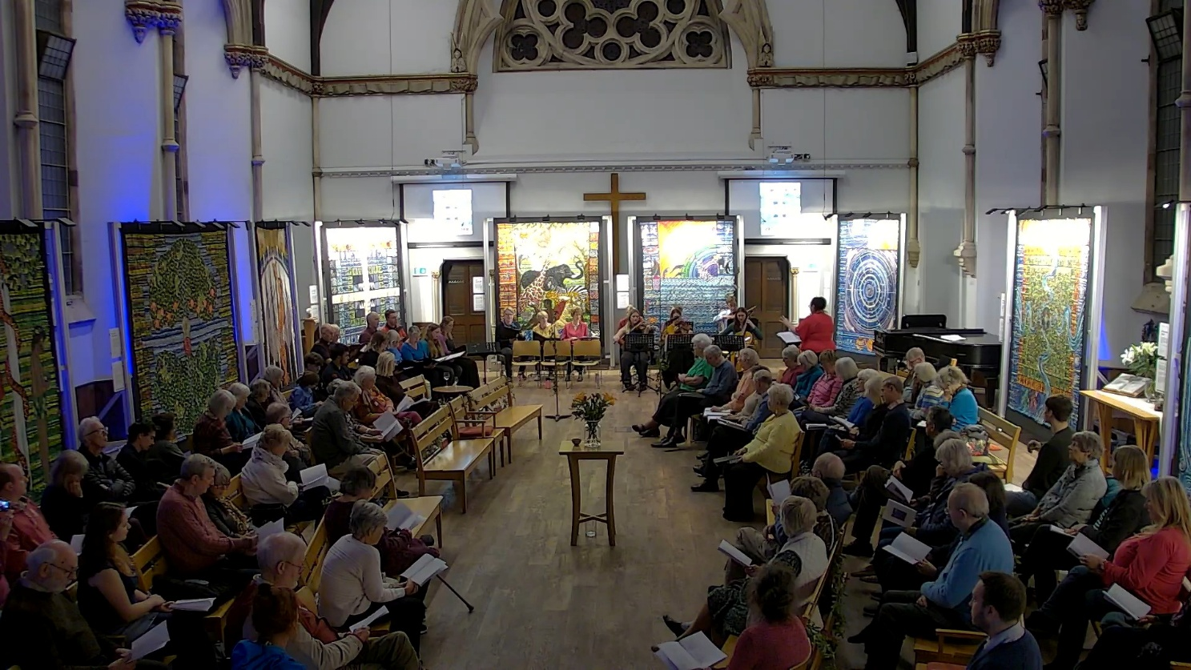
The event finished with an evening of music, readings and meditations - a deeply moving and fitting way to end the exhibition.

Pray for wisdom
As we are preparing this edition of the EcoNewsletter news is coming through of Hurricane Melissa which has devastated Jamaica, Cuba and Haiti. Climatologists tell us that the ferocity of the hurricane came about because of the warming of the seas, almost certainly because of human use of fossil fuels. We are reminded that we are part of one community and that the impacts of our actions may appear many thousands of miles away. Please pray for wisdom for all the national and NGO delegations at the COP.

Environment and faith webinars
The District Environment Team is running webinars via Zoom about creation care. We hope these will encourage you and equip your church in its work for God’s earth.
The webinars so far booked are:
Monday 24 November: Creation Care – a Global viewpoint – Caroline Pomeroy from Climate Stewards
Monday 9 February: Creation Care and Young People – Lynne Norman, Children and Youth Officer in the Connexional Team (Postponed from October)
Both of these are at 7.30p.m.
Everyone is welcome, simply book your place by emailing Ian Souter at ian.souter@methodist.org.uk

Going for Gold
Many churches are involved in the EcoChurch programme (currently 58 churches in the District have an award). But the scheme has changed and some churches are finding it more difficult. Ian McKay (former chair of A Rocha UK) who spoke at our first District webinar this year welcomed that fact.
He shared with us that the bronze level award is largely about doing the right things; the silver award is now much more about embedding creation care in the life of the church, so that every facet of what we do, not only as a church but as individual Christians is impacted by our care of creation.
When you get to the gold award, the aim is to ensure we are impacting our community beyond the walls of the church. The church engages with the issues wherever they find them, campaigning and looking for opportunities to make a difference. It is this process of embedding creation care into our life that is most important. It is not just about ticking boxes to say we are doing the right things but about making this all part of who we are.
In the end of course it is not the award that matters, it is that as the people of God we are doing all we can to conserve and even enrich the world in which we live.
Hope in God’s Future
In 2011 the Methodist Conference adopted a report about the environmental problems we face called Hope in God’s future. At this year’s conference a report was received as a first stage in the updating of this statement. You can find this at https://media.methodist.org.uk/media/documents/conf-25-30-hope-in-gods-future-update.pdf The aim is to have a new definitive statement at the 2027 Conference. Please read the report and maybe pass on comments.
Next Edition will be produced before COP30 and if you have news to share please send an article (with pictures if possible) to Ian Souter at souterfam@aol.com
Korea Invitation
Before you get over-excited, this is not a chance to burn 3 years of carbon footprint in one go on a flight to South Korea. The Lausanne Movement, which started in 1974 as a gathering largely of evangelical church leaders developed a stream of social concern. It met this year in South Korea and in the wings of this there was a meeting of the Global Creation Care Forum.

Out of this has come a document affirming the place of creation care in the gospel, suggesting areas of action and finally inviting people to express support for Christian creation care. That’s the invitation and it’s open to all whatever your theology. If you would like to read this document please go to https://lausanne.org/statement/good-news-for-all-the-earth. You may find this document is a helpful discussion starter and you may feel called to respond to the invitation to express your support.

Can you help? We are looking for volunteers to take over the compiling and editing of this Newsletter, starting with the next issue. If you would like further information on this rewarding role please email, Rev Ian Souter on souterfam@aol.com.

Please send your church environment news to Ian Souter at souterfam@aol.com by 21 January 2026

Please feel free to copy this newsletter or any parts you feel relevant to your situation and use it in church notices or magazines. You are welcome to forward it to others who may be interested.

If you received this newsletter direct from us it is either because you attended the Eco Church workshop in 2020 and indicated that you wished to remain on our mailing list and receive updates from us, or you have requested to join the list. If that is no longer the case, please just drop an email to us and we will remove you from the list. If you received it from your Circuit Office please contact your Circuit Administrator.

