
Greetings for the New Year!
Our first service together in 2026 is grounded in the annual Covenant Service. An invitation for us to renew our covenant relationship with God. It is a reminder of God’s constant faithfulness enfolding us with generous love, wherever we find ourselves in life, and wherever God leads us into this new year.
This year, I have reflected on the symbolism of stones as a reminder of the promises of God.
As Moses prayed for the Israelites before they entered the Promised Land, he asked them to take the stones from the fields and to make an altar of them, so that they could offer their sacrifices to God (Deuteronomy 27: 6). The importance of this, is that they had been a wandering people, but now they would be able to settle, to clear the land and to grow crops. And, for them to be able to pick the stones out of the fields, will have meant they would have trusted God’s promise, and walked in them to settle in Canaan.
Later in Joshua 4, as the Israelites crossed the Jordan, into Canaan, the waters parted, and twelve stones from the now-dry-riverbed were picked up and taken to the other side. Once everyone had crossed over, the waters came together again. The twelve stones became reminders of God’ s promises.
The Covenant Service liturgy also includes Romans 12: 1-2, where Paul urges believers to offer themselves as “living sacrifices, holy and pleasing to God, as our spiritual act of worship”.
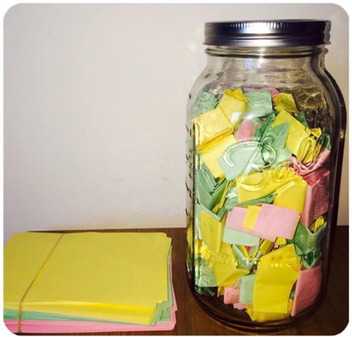
May I suggest there is a link here between the Old and New Testament readings, which could benefit us in 2026. As we share together in the Covenant service, and as we offer ourselves again as living sacrifices, can we do this symbolically on the altar of God’s promises.

And to help us with this, may I suggest that we keep a “God’s promises” jar near us this year. Every time you notice God close to you, that you write a note and put it in the jar. Then, at the end of the year, we can tip the jar and remind ourselves of all that God has done in our lives in 2026.
Every blessing for this coming year.
Jimmy

